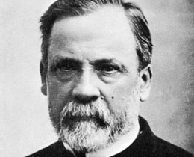
Overview
With a focus on the sciences, learners will use their own experiences and research techniques to investigate microbes, initially in the context of research into the life and work of Louis Pasteur. Learners will be given the opportunity to relate symptoms and illnesses to diseases caused by microbes. Using the work of Louis Pasteur as a stimulus, learners will explain how germs are spread and discuss how some methods of preventing and treating disease have benefited society. Learners could be asked to start a campaign to promote an aspect of hygiene e.g. handwashing.
Learners will be encouraged to negotiate their own success criteria and use these to evaluate the success of their campaign
These learning opportunities promote links with health and wellbeing and numeracy.

Stirling Castle 260

If for

Sciences experiences and outcomes explored:
Biological Systems:
Body systems and Cells
By investigating some body systems and potential problems which may develop, I can make informed decisions to help me to maintain my health and wellbeing.
SCN 2-12a
I have contributed to investigations into the role of microorganisms in producing and breaking down some materials.
SCN 2-13a
Other curriculum areas explored:
Health and Wellbeing:
Having learned about cleanliness, hygiene and safety, I can apply these principles to my everyday routines, understanding their importance to health and wellbeing.
HWB 2-33a
Mathematics:
I have carried out investigations and surveys, devising and using a variety of methods to gather information and have worked with others to collate, organise and communicate the results in an appropriate way.
MNU 2-20b
I can display data in a clear way using a suitable scale, by choosing appropriately from an extended range of tables, charts, diagrams and graphs, making effective use of technology.
MTH 2-21a

Responsibility of all:
Health and Wellbeing

Themes across learning:
ICT

Overview of learning

Possible prior experiences
Learners will have come across ways of keeping themselves healthy including the importance of handwashing and brushing teeth.

Learners may be aware of, and use, words such as germs, bacteria and microbes. Learners may also know some of the uses of microbes for example, in food production and their role in the break down of some materials.

Learners may have used vocabulary relating to microbes, for instance when making bread or composting materials in school or at home. They may have had practical experience of their use.

Learners may be aware of some of the causes of illness and disease and may have linked some of these to microbes (bacteria, viruses or fungi).

Learners may have researched some important figures from the past and be able to relate their discoveries to improvements in health over time.

Learners may have had practical experience in the use of microscopes and be aware of the existence of living organisms too small to see with the naked eye.

Possible learning opportunities
Learners use practical activities and research to identify the role of microbes in everyday life.
As a class learners could:
Devise a list of success criteria for their research or health campaign, for example:
Be able to name some of the various types of microbes present in the environment.
Promote the understanding of the contrast between the positive uses of microbes e.g. food production, with the negative side e.g. disease.
Convey information on microbes relevant to their target audience.
Highlight wider health implications as part of their work e.g. over use of antibiotics, prevalence of tooth decay.
Find out about some current research within health and medicine, linked to microorganisms.

Within their groups learners could:

Take part in practical activities to further their knowledge and understanding of the “hidden world” of microbes.
Design a poster to promote an aspect of health and hygiene within school or the wider community e.g. poster to be displayed in toilets promoting correct handwashing procedures.
Take part in an assembly or talk to others to communicate their findings and promote healthier lifestyles in relation to hygiene.

Learners could devise questions to help decide how effective their research, practical work of healthy living campaign has been, for example:

Does it fulfil the success criteria?
Could it be improved in any way?

After peer and self-assessment pupils should have the opportunity to reflect and suggest improvements to their presentations/campaigns.

Possible evidence
Observation notes from practical work
Results from surveys and questionnaires
Research into microbes and the scientists involved in important discoveries
Designs for posters/leaflets
Success Criteria checklist
Photographs/video of the activities
Video of handwashing technique/ health promotion videos
Peer evaluation sheets /criteria produced by learners
An understanding of the role of health professionals linked to visits from outside agencies e.g. NHS
Learners will have taken part in activities that demonstrate how some pathogens are spread and will be able to suggest ways of preventing transmission between people.

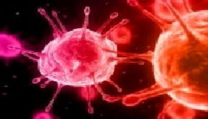
The “hidden” world of microbes
Microorganisms include:
Fungi
Viruses
Algae
Bacteria
Protozoa

Image of viruses
After finding out about the life and work of Louis Pasteur many learners will be keen to find out more about the role of microbes in our daily lives and how our knowledge and understanding of this area has changed (and continues to change) over time. Other important figures involved in the history of microbiology, vaccines and disease could form a basis for further research.

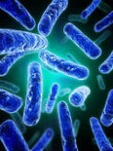
Some learners may have suffered from a disease caused by a particular microbe. These common diseases could be researched and details about the symptoms and appropriate treatment could be included. A class survey of common diseases could be conducted if appropriate. The way that certain common diseases are spread could also be examined.
Some common diseases caused by microbes:
Influenza (Virus)
Athlete’s foot (Fungus)
Chicken pox (Virus)
Tooth decay (Bacterium)
Food poisoning (Bacterium)
Malaria (Protozoan)
Ringworm (Fungus)
Meningitis (Bacterium)

Some learners will have used microscopes and will be aware that there are some organisms that are too small to be seen with the naked eye. Although some microbes (some algae and fungi) are visible under a microscope many more are only visible under a scanning electron microscope. Images from these can be examined by the learners. Often the names given to microbes are associated with their colour or shape.
Image of bacteria
Microorganisms are very tiny living things, so small that we cannot usually see them. Learners may be aware of the existence of microorganisms (microbes) and may even be able to name some of them. Many learners will associate microbes with disease but are usually surprised to discover that actually fewer than 5% of microbes cause potential harm to humans. Many microbes are helpful, some are even essential to our health.

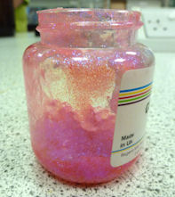
Practical activities: Glitter spread
This practical activity will demonstrate how microbes are transferred from person to person, either via direct physical contact or indirect contact with hard surfaces and other objects. The passing on of infectious disease is called transmission. Glitter gel (figure 1) is used to represent the microbes present on the hands after sneezing, touching the nose and mouth or touching a contaminated surface.
The class could be split into two groups and should sit in two separate circles. One learner from each group should apply a teaspoon of glitter gel to their hand as if they had just sneezed (figure 2). One of these learners should wash their hands immediately the other should not. Once both have returned to their circle the chosen learner should take a piece of everyday equipment e.g. a ruler or pencil and they should handle it. Then the object should be passed from person to person around the whole group. After it has returned to the original source all the learners should then carefully examine their hands and the object (figure 3). The group with the learner who did not wash their hands should see how much glitter has spread amongst the group. The results should be compared to the group whose volunteer did wash their hands at the start. This illustrates how important handwashing is in the prevention of disease transmission.
Alternative practical activities could involve one person with “contaminated” hands shaking hands with one person who then shakes hands with another and so on around the class and then transmission checked at the end. Paper could also be handed around or given out and inspected (figure 4).
This activity can also be used to judge the efficacy of current handwashing techniques as it allows learners to see any areas of the hands that retain glitter after application and initial washing. This may indicate areas where extra attention should be paid in future. Current advice on handwashing is available from NHS Scotland.
Figure 1: Glitter gel suitable for use on skin

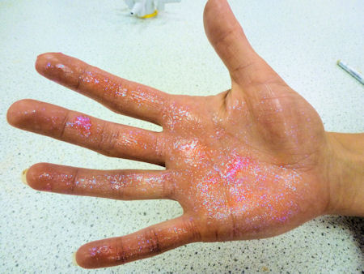
Figure 2: Hand coated in a glitter “sneeze”

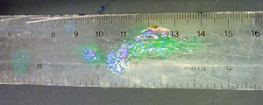
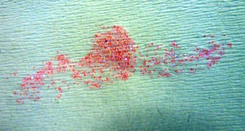
It is important to only use glitter gel suitable for use on the body and to avoid contact with the eyes. Take into account any skin conditions/allergies and ensure that the activity is age appropriate. For further advice refer to the updated ASE publication “Be Safe” or contact SSERC.

Figure 3: Ruler passed by unwashed hand
Figure 4: Paper touched by unwashed hand

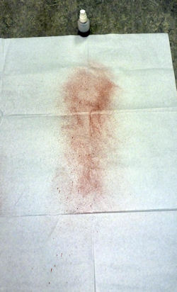
Coughs and sneezes spread diseases?
The practical activities could involve an investigation into how far a sneeze can spread and also investigate the relationship between the height of the person sneezing and the spread of droplets in the sneeze. Droplets from the lungs, expelled via a sneeze, can contain microbes that cause disease. One of the symptoms of a disease might be coughing and sneezing. Learners will be aware from the glitter spread activity that the transmission of microbes can occur through contact with hard surfaces or via touch. Some microbes can stay alive on hands for a number of hours. It is important to remember that colds and flu are spread by touch as well as by coughing and sneezing.
Figure 1: Spread of “sneeze” droplets demonstrated using red food colouring

The spray pump should be clean and not have previously contained any chemicals or hazardous substances.
Take care not to allow the food colouring to be sprayed directly at anybody.
Food colouring may stain fabric, clothing, floors and desks so ensure suitable materials are used to protect surfaces/clothing.
This simple investigation into sneezes uses a small spray pump bottle, food colouring and a white paper table cover.
Food colouring is placed into the spray pump bottle. The food colouring is used to allow a visual check of the spread of the droplets in the “sneeze” onto the white paper.
The pump is placed on the floor and pressed three times to represent the sneeze (the bottle remains in a fixed position). The spread is examined and possibly photographed (figure 1).
A clean white table cover is placed under the pump in the same position and the pump is now raised 25cm (the height could be decided upon by the learners, but should not involve climbing onto chairs or furniture). The pump is pressed three times again. Have the droplets in the sneeze spread further this time?
This can be repeated for a height of 50cm, 75cm and 1m and results compared. Careful examination is needed as the droplets may appear faint as they spread out further. This activity could be conducted outside but the wind may affect the results. Does the height of the person sneezing affect the way the droplets spread?
This provides a visual indication of how far droplets in a sneeze can spread and reinforces the need to catch the droplets using a tissue (NHS catch in, bin it, kill it campaign) or to wash hands if they are sneezed onto. This might be a good point to discuss other occasions when washing hands is recomended. What advice could the learners now share with others?
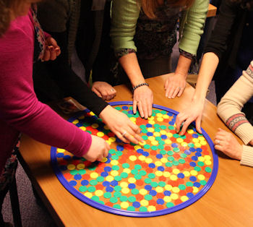
How do microbes spread?
Microbes are too small to see with the naked eye and can reproduce at an astonishing rate. This activity can be used as an analogy to give learners an insight into the size and scale of microbes and also to illustrate how just how quickly bacteria can divide.
A hula-hoop and counters (or other similarly sized objects) can be used to give learners some idea of the sheer number of microbes that can occupy a very small area. The hula-hoop represents a pin-head and each counter represents a bacterium. Of course, bacteria vary in size depending on their variety; the counters represent one of the larger types of bacteria.
Learners could first estimate how many microbes could fit on this area. Counters are then placed within the hoop and once the area is completely filled, numbers are counted. To make counting simpler counters could be pre-bagged into 10s or 20s and the number of bags emptied during the activity counted up and a simple multiplication carried out. Further calculations could be done to work out how many similar sized microbes could cover a ruler or book.
A single-celled bacterium reproduces by diving in half producing two, identical, new cells. If conditions are favourable, with plenty of nutrients and surroundings at the optimal temperature, some bacteria can divide very rapidly indeed. In 7 hours one bacterium could generate over 2 million bacteria! This is why it is so important to store food correctly and to wash hands frequently.
This simple demonstration requires a hula-hoop and approximately 500 counters per group. The counters could again be placed in bags of 10 for ease of counting. As before the hula-hoop represents a pin-head and the counters take the place of bacteria. How long will it take for the bacteria to cover the pin-head if they reproduce 20 minutes?
Place 10 counters in the hula-hoop and set a timer for 20 minutes. At 20 minute intervals each counter should be joined by another, representing the division of the bacteria. The number of counters (bacteria) should be recorded and the process repeated until the entire surface is covered. The results could be plotted onto a graph. Learners might wonder if the bacteria would keep on dividing indefinitely, this could provide an interesting area of research.
Learners may wonder why humans are not constantly suffering from microbial infections and disease! It is important to understand the relationship between humans and microbes in its proper context; alongside natural immunity and modern medical techniques e.g. vaccination. There is current debate surrounding the overuse of antibiotics and this may well have implications for the future of human health.
Figure 1: Hula-hoop and counters
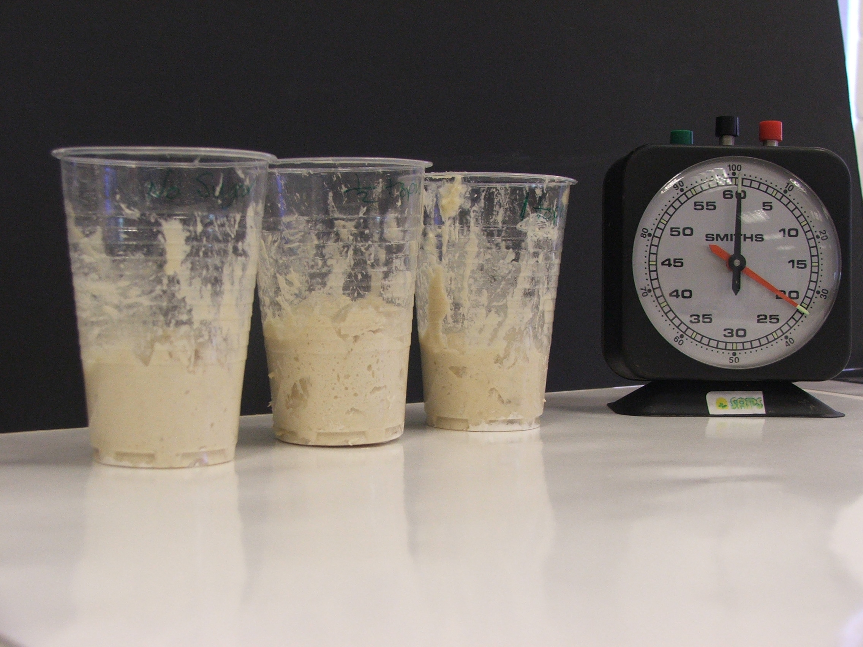
Further work on microbes
There are a number of further activities that relate to microbes, including investigations into yeast, food production, composting and decay (figure 1&2).
Some of these activities involve the growth of microbes so advice must be sought in order to keep within health and safety guidelines.
For further information and advice, including ideas for practical work, contact Scottish Schools Education Research Centre (SSERC) sts@SSERC.org.uk Alternatively consult the current version of ASE publication “Be safe” which provides health and safety advice for primary schools.
Figure 1: Experiments with dough

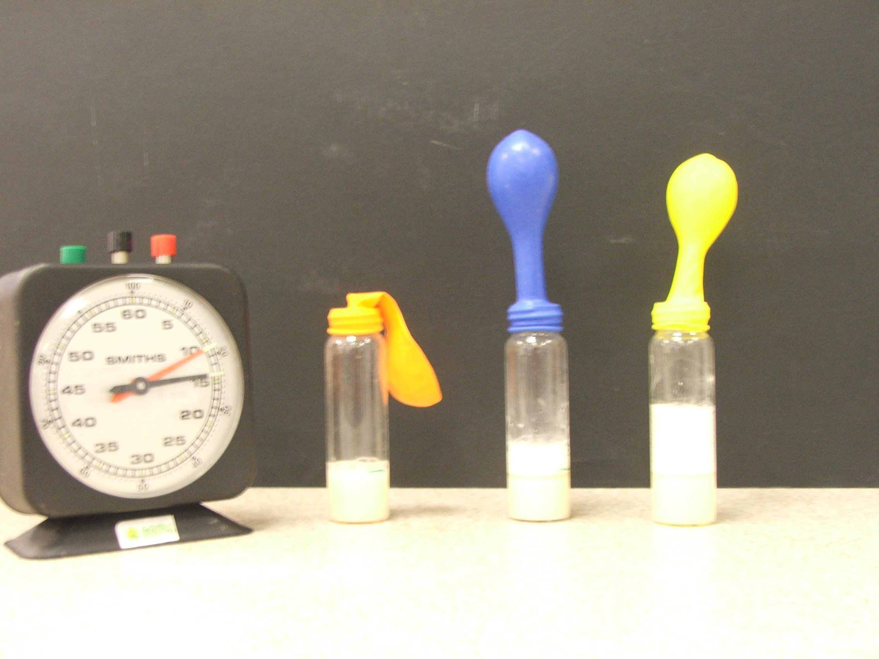
Figure 2: Experiments with yeast and fruit juices

