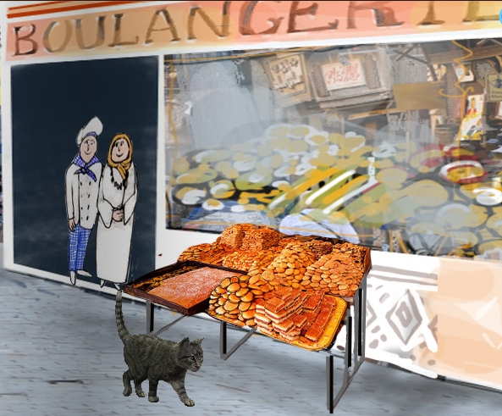
Overview
Learners will use The Hungry Cat e-book set in the shopping street of Rue Yacoubian as a context for the suggested learning opportunities.
With a focus on technologies, learners will use internet search engines and Google Earth to research and investigate the similarities and differences between the architecture and layout of a typical shopping street in Cairo and Scotland. They will use this knowledge to design and create their own replica of Rue Yacoubian. Learners will be encouraged to negotiate their own success criteria and use this to evaluate their final product.
These learning experiences offer opportunities for links with mathematics as learners will require an understanding of scale and 3D net to complete the suggested activities.

Stirling Castle 260

Technologies experiences and outcomes explored
Throughout all my learning, I can use search facilities of electronic sources to access and retrieve information, recognising the importance this has in my place of learning, at home and in the workplace.
TCH 2-03b

During practical activities and design challenges, I can estimate and measure, using appropriate instruments and units.
TCH 2-13a

Through discovery and imagination, I can develop and use problem-solving strategies to construct models.
TCH 2-14a

Responsibility of all:
I can use my knowledge of the sizes of familiar objects or places to assist me when making an estimate of measure.
MNU 2-11a

Other curriculum areas explored:

Through practical activities, I can show my understanding of the relationship between 3D objects and their nets.

MTH 2-16b

Themes across learning:
Creativity

Possible prior experiences

Watch the Egypt e-book

List the shops visited in the story in chronological order

Name the shops in English and French

Using an image search engine, compare and contrast the appearance of these shops in a Scottish City and in Cairo

Use Google Earth to view a street in Cairo and make observations e.g appearance, size, colour

Consider and investigate the importance of scale when designing a street

Investigate which 3D nets would be appropriate to be used in order to create a street. e.g cube, cuboid, prism.

Explore the possibilities for creating 3D models using Trimble SketchUp

Challenge
Learners use a design brief to create a 3D model of Rue Yacoubian:
As a class, learners could:
Devise a list of success criteria for their street, for example:
length of the street
shops must be in correct order from the story
materials that can be used
names of shops must be in French and English
3D nets must be used to make the shops

Within their groups, learners could:
Plan the layout their street
Construct their street using an agreed range of materials. For example, cardboard, paper, paint, etc
Use 3D nets in order to create the buildings

Learners could devise questions to help decide how effective their design is, for example:
Does it fulfil the success criteria?
Does your design include the shops’ names in the story?
Is it realistic in appearance?
Could it be improved in any way?

After peer and self assessment, pupils should have the opportunity to reflect and modify their street.

Possible evidence
Observation notes
Success criteria checklist
Planning sheets
Photographs of the process
3D model
Evaluation sheets

Overview of learning

