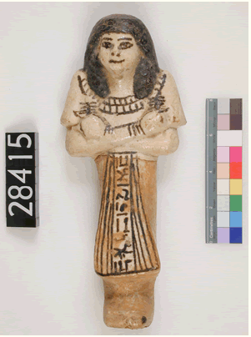

I see… __________________________________________________________________________________________________________________________________________________________________________________________________________________________________________________________________________________________________________________________________________________________________________________________________________________________________________________________________________________________________________________

I think … __________________________________________________________________________________________________________________________________________________________________________________________________________________________________________________________________________________________________________________________________________________________________________________________________________________________________________________________________________________________________________________

I wonder … __________________________________________________________________________________________________________________________________________________________________________________________________________________________________________________________________________________________________________________________________________________________________________________________________________________________________________________________________________________________________________________

