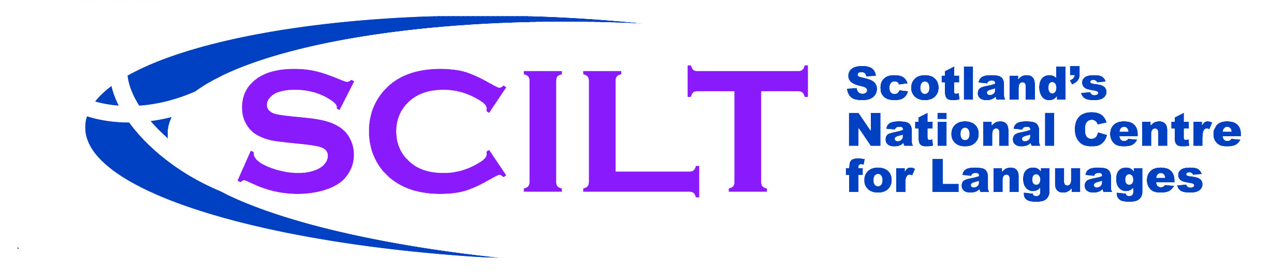




Name: ………………………………….......

My European Language Portfolio


About your European Language Portfolio
Your European Language Portfolio (ELP) allows you to record and comment on all the language learning and cultural experiences you have in and out of school.
There are three parts to your ELP:
In My Language Passport you can;
- Make a summary of your overall progress in languages;
- Record your language learning achievements;
- Ask your teacher to evaluate your learning
In My Language Biography you can;
- Comment on the languages that exist in the world around you;
- Think about the way that you learn languages;
- Evaluate your progress in different skill areas: speaking, talking with others, listening, reading, writing and intercultural understanding;
- Say what is going well;
- Say what you need to improve
In My Dossier you can
- Gather any materials that demonstrate your language learning, achievements and cultural experiences.
Examples of things you might find in “My Dossier” are;
- everyday work that you have done in class
- letters/emails that you have written or received
- photographs
- learning logs
- a reading record
- posters
- certificates or other awards
- a description of an activity or an experience
- extracts from your learning journal…

…in fact, almost anything that acts as evidence of the experiences you have recorded in your biography or passport can be included in “My Dossier”!

MY LANGUAGE PASSPORT
A record of my progress in learning languages

“Bla Bla Bla Bla...”



European Language Portfolio: registered model No.2014.R013

“The United Kingdom is a member of the Council of Europe, which makes it part of a family of 47 countries stretching all the way from Iceland to Azerbaijan. The millions of young people who live in those countries share many experiences and interests but also have different languages, cultures and histories.
The Council of Europe aims to help you to understand and respect other people and the things that make them different. Your European Language Portfolio is designed to help you to learn new languages and understand other cultures.”

European Language Portfolio: registered model No.2014.R013
Awarded to: SCILT - Scotland’s National Centre for Languages, United Kingdom
This model conforms to common Principles and Guidelines established by the Council of Europe’s Steering Committee for Education (2000, rev. 2011)

How to use my passport

This passport gives you a chance to record your achievements and overall proficiency in different languages in and out of school.
- In “My Language Achievements”, under “Type of achievement”, you might record information about certificates or awards you receive, competitions you enter, class test scores, positive language reports or feedback from your teacher or peer, or any other achievement.
- The passport will be passed onto your new teacher at primary or secondary school, who will be very interested in the information which you and your teacher record here.
- Your teacher can provide you with extra copies of each page if you need them.

Using different languages
Take notes in the right hand column to show how you use your knowledge of different languages for different purposes.

I use my knowledge of different languages when: | When? Which language(s)? Other details
I see them on TV
I read them in a book or newspaper
I hear them in a song
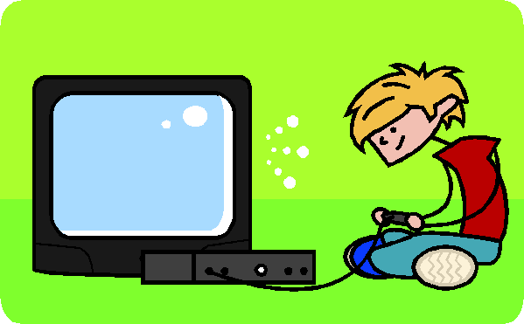
I play a game
I speak with my friends
I speak with my family
I contact someone in another country
I notice how other languages influence my Mother Tongue


Interesting things I notice about other languages
___________________________________________________________________________________________________________________________________________________________________________________________________


My Language Achievements

Language | Type of achievement | Date achieved
Use this page to record your wider language achievements in and out of school.

Bravo!
祝贺您
Félicitations!
مبارک ہو
Congratulations!
¡Enhorabuena!

My Progress in Languages
For each language, colour the table on the next page according to the example below. You may partially colour boxes as you go.
EXAMPLE:
Regularly review your learning using “My Language Biography”. Colour the boxes to show your progress in each level.
 | Language: | A1  (CfE 2nd level) |  |  |  | A2  (CfE 2nd– 3rd level)
 | Spanish | I have set this as a learning target | In progress |  | Target achieved | I have set this as a learning target | In progress | Target achieved
 | Listening
 | Reading
 | Talking with others
 | Speaking
 | Writing

My Progress in Languages
Regularly review your learning using “My Language Biography”. Colour the boxes to show your progress in each level.

 | Language: | A1  (CfE 2ndlevel) |  |  | A2  (CfE 2nd – 3rd level)
 | ___________________ | I have set this as a learning target | In progress | Target achieved | I have set this as a learning target | In progress | Target achieved
 | Listening
 | Reading
 | Talking with others
 | Speaking
 | Writing

Better and Better: Teacher’s Page
Quite well

A Summary of ______________________’s progress
Language: __________________________________

With reference to the statements of the Experiences and Outcomes, by the end of P7 the pupil has learnt the necessary skills to meet the following criteria consistently (taken from the Principles and Practice for Modern Languages):
- Give short presentations about themselves and others.
- Take part in simple conversations and transactions.
- Understand classroom instructions and personal information.
- Enjoy listening to a stories, songs and poems.
- Read aloud simple texts.
- Read and understand texts.
- Write short texts about themselves and others, including giving their opinion.
If the learner fulfils the above, even if some areas are weaker than others, the learner has achieved A1 (CEFR) or 2nd Level (CfE).
Please write an evaluative comment on what this learner can do.
_______________________________________________________________________________________________________________________________________________________________________________________________________________________________________________________________________________________________________________________________________________________________________________________________________________________________________________________________________________________________________________________________________________________________________________________________________________________________________________________________________________________________________________________________________________________________________________________________________________________________________________________________________________________________________________________________________________________________________________________________

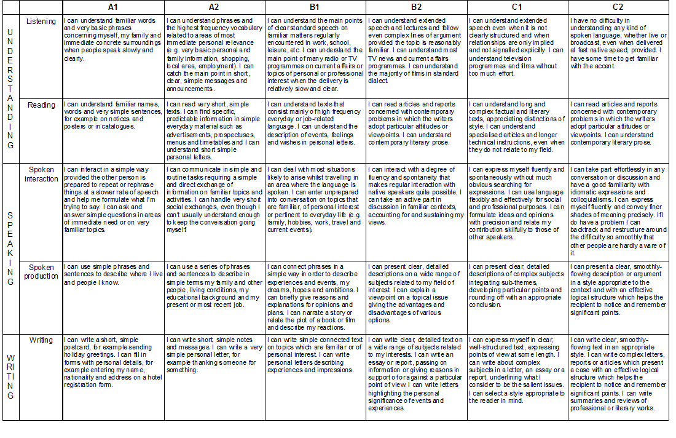Common European Framework of Reference for Languages: learning, teaching, assessment
Common Reference Levels: self-assessment grid www.coe.int/portfolio

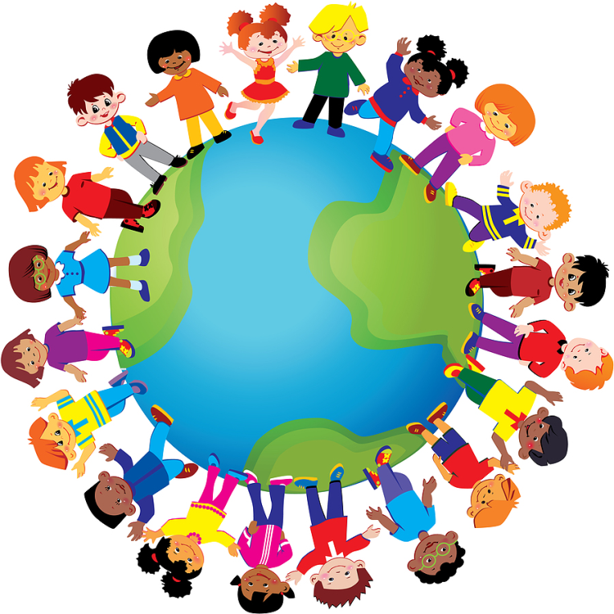
My Language
Biography
European Language Portfolio: registered model No.2014.R013

How to use my biography

This booklet is yours! You can use it to record your progress in languages that you are learning in school or it could be used to show your progress in other languages that you use at home or those you encounter in the wider community.
Everyone will have their own booklet, so it will show different information for each person in your class. Your teacher can provide you with extra copies of each page if you need them.
There are several sections, here’s a quick guide on how to use them:
Languages I know:
Highlight or colour the different languages you use, hear or start to learn. You may wish to add other ones into the blank spaces!
Languages in my world
This is your chance to record your impressions about the languages around you and the people you meet. You may wish to add more people in the blank spaces.
Languages in my school and in my community
This is your chance to build a picture of the variety of languages used in your school, by members of school staff and the wider community.
Joining Up Languages
As you learn, use this page to show your understanding of how languages influence each other.
How I learn
This section helps you reflect on your progress and how you learn languages. It might give you some tips on how to get better too!
My Languages Journey
This section is split into different skills: Listening, Writing, Reading, Talking with Others, Speaking and Intercultural Experiences. Here, you will have the chance to say how well you are doing in each of these areas.

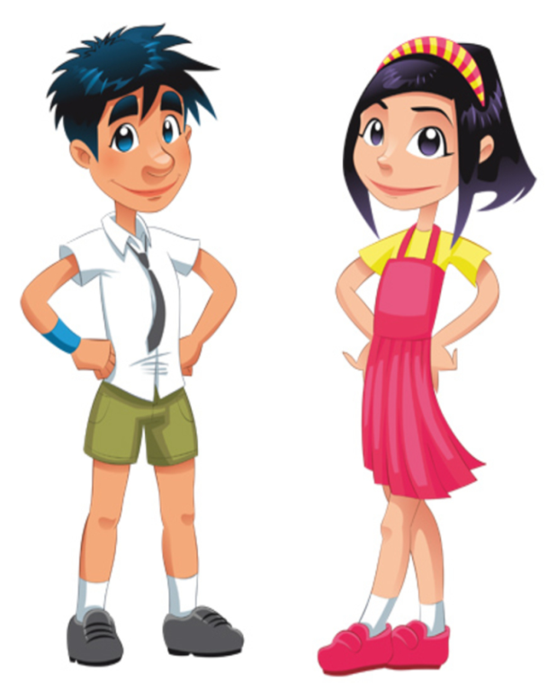
Languages I Know
Punjabi
ਪੰਜਾਬੀ
Polish
Polski
Scots
Scots
Italian
Italiano

Russian
Pусский
Gaelic
Gàidhlig
French
Français

German
Deutsch

Urdu
اردو

Spanish
Español
Chinese
中國的
Welsh
Cymraeg

Portuguese
Português

English
English

Arabic
العربية

Languages in my World
I meet people who speak another language

 | Details
 | Who? | Which language? | When we met, I thought…
At school

At home

On holiday
In my community


Online

Languages in my school and in my community
In my school, we can learn (please write down which languages): ………………………………………………………………………………………………………………………………………………
At school, we have started to learn: …………………………………………………………………………………….
I like learning this language because: ………………………………………………………………………………………………..
My teacher can speak: …………………………………………………………….
In the future I would perhaps like to learn: …………………………………………………………………………………………………………………………………………….
People | Where is your favourite place to go on holiday? | Do you know any languages or have you tried to use any different languages on holiday? | Which languages did you learn at school? | Which language would you most like to learn? Why?
Classroom Assistant
Teacher
Depute Head
Head Teacher
Janitor
Canteen Staff
Cleaner
Parent/Carer
Interview members of your school community and find out about their experience of other places and languages:
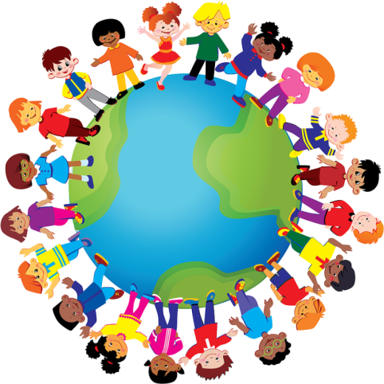
Joining up Languages
My Mother Tongue is __________________________________
Languages which influence my Mother Tongue are:
______________ ______________
______________ ______________
Words in my Mother Tongue which come from other languages:
Words | The language they come from

Languages which are influenced by my Mother Tongue are:
______________ ______________
______________ ______________
Words from my Mother Tongue which are used in other languages:
Words | The languages they are used in

How I Learn Languages

Tick all the activities that help you learn best.
You may wish to add any other activities that help you in the blank spaces provided.
I learn well when I….
…work on my own
…work in pairs or groups
…use my knowledge of other languages to help me understand new words
…revise vocabulary
…study grammar
…choose my own texts to read, listen or watch
…check that my work is accurate
…check that the work of my peers is accurate
…use word banks and glossaries
…use a highlighter to highlight words I know, words that look familiar and key words I don’t know
…use a dictionary to understand key words I don’t know
…use a dictionary to find out more information about words or phrases
…create my own word banks and glossaries
…plan my work thoroughly
…use gesture, body language or facial expression to support what I say or to understand what is
being said
…act out the meaning of things I hear
…play games like “Simon says”
…sort information into tables or diagrams
…use ICT to support my learning
…use images, context or other clues to help me understand
…figure out my own strategies for reading, listening, writing and speaking
…use examples or models answers to help me do an activity


I would like to improve my ability to….
My Languages Journey Listening A1 - CfE 2nd level
Language:___________________________
When people speak slowly and very clearly…

Descriptor | I have set this as a learning target | I can do this with some help | I can do this independently
I can understand words and phrases that are frequently used in conversation like “hello”, “goodbye” and “how are you?”
I can understand routine phrases like “please” and “thank you”
I can understand basic personal information like, name, age, where someone lives
I can understand short instructions spoken by a familiar voice
I can understand familiar words in songs, rhymes and poems which use simple language
I can understand familiar language relating to myself and my family
I can match words I hear with objects or images
I can pick out familiar words I know from a short announcement

Use this list to think about your progress. Tick (✓) the boxes that apply to you and write in the date. Use the empty boxes to record other targets you have set and in which you are progressing.

My Languages Journey Listening A2 - CfE 3rd level
Language:___________________________
When people use phrases and high frequency words…

Descriptor | I have set this as a learning target | I can do this with some help | I can do this independently
I can understand the gist of short video clips and cartoons
I can understand key messages in short public announcements in school, in shops or at the railway station/bus station/airport
I can understand a short story read by a familiar voice, supported by gesture or images
I can understand when other people speak about themselves and their families
I can understand a short conversation between two or more speakers on a familiar topic like school, daily routine, or hobbies
I can understand when someone gives me clear directions on how to get somewhere

Use this list to think about your progress. Tick (✓) the boxes that apply to you and write in the date. Use the empty boxes to record other targets you have set and in which you are progressing.

My Languages Journey Writing A1 - CfE 2nd level

Language:___________________________
When I use simple, familiar language to exchange straightforward information…

Descriptor | I have set this as a learning target | I can do this with some help | I can do this independently
I can write a short biography of myself
I can label objects
I can write a short physical description of myself including my eye and hair colour, and my height and build.
I can write a short physical description of someone else
I can write short statements to say what I like/dislike
I can write short messages for birthdays, Christmas, New Year and/or other feasts.
I can write simple sentences about familiar topics like my daily routine, my school and my hobbies
I can use some connectors like “and”, “but” and “then” to link my ideas together
I can complete forms which require personal details, such as my name, date of birth, nationality and address

Use this list to think about your progress. Tick (✓) the boxes that apply to you and write in the date. Use the empty boxes to record other targets you have set and in which you are progressing.
My Languages Journey Writing A2 - CfE 3rd level

Language:___________________________
Using straightforward language and simple constructions…

Descriptor | I have set this as a learning target | I can do this with some help | I can do this independently
I can write a short letter/text/email of invitation to a party, meeting or other gathering.
I can write a short email, text or letter to accept an invitation to go out or to express my apologies
I can use simple forms of addressing, greeting and thanking others
I can write short, basic descriptions of events, past activities or personal experiences
I can write a short description of an image or a sequence of images
I can write an imaginary biography about someone else
I can use a wider variety of connectors (like “firstly”, “next”, “then”, “later” & “finally”) to add structure to my writing
I can express a simple opinion and use words like “because” to give a simple reason for this

Use this list to think about your progress. Tick (✓) the boxes that apply to you and write in the date. Use the empty boxes to record other targets you have set and in which you are progressing.

My Languages Journey Reading A1 - CfE 2nd level

Language:___________________________
When short written texts about familiar topics use very simple language and structures …

Descriptor | I have set this as a learning target | I can do this with some help | I can do this independently
I can understand familiar names and key messages on posters and notices
I can understand straightforward written instructions about schoolwork
I can understand which personal details are required by a simple form or profile
I can understand personal details written about someone else on a simple form or profile
I can find the information I need, e.g. times and locations, from timetables, posters and schedules
I can understand texts about familiar topics like my family, my daily routine, my school and my hobbies
I can identify familiar words and phrases in a new text
I can read and understand poems, songs and rhymes
I can match words that I read with images
I can understand a very simple dialogue or script
Use this list to think about your progress. Tick (✓) the boxes that apply to you and write in the date. Use the empty boxes to record other targets you have set and in which you are progressing.
My Languages Journey Reading A2 - CfE 3rd level

Language:___________________________
When texts are short and use simple language…

Descriptor | I have set this as a learning target | I can do this with some help | I can do this independently
I can understand a set of predictable instructions supported by images or tables
I can understand the gist of a fictional text, sometimes supported by images
I can understand emails, letters or postcards about someone’s everyday life or holiday
I can understand a brochure or an advertisement which describes something familiar, like a sporting activity, a city, or a restaurant
I can choose what I’d like to eat from a menu
I can find specific information I need in a catalogue or website
I can understand everyday signs and notices in a wide variety of public places

Use this list to think about your progress. Tick (✓) the boxes that apply to you and write in the date. Use the empty boxes to record other targets you have set and in which you are progressing.

My Languages Journey Talking with others A1 - CfE 2nd level

Language:___________________________
When talking to someone who speaks slowly and clearly, and who is ready to repeat what they say and prompt me if needed…

Descriptor | I have set this as a learning target | I can do this with some help | I can do this independently
I can use accurate pronunciation so others understand me
I can use words like “hello” and “goodbye” to join and leave a conversation
I can ask how people are and react to news
I can ask for things and can give people the things they ask for
I can answer simple questions about my name, age and where I live and I can ask others for this information
I can answer simple questions about my family and ask someone else about their family
I can use phrases such as “next week”, “last Friday”, “in November” or “three o’clock” to indicate time
I can ask for and follow very simple instructions and directions
I can enquire about the price, quantity or measurement of an item
I can understand prices, quantities and measurements
I can say when I don’t understand

Use this list to think about your progress. Tick (✓) the boxes that apply to you and write in the date. Use the empty boxes to record other targets you have set and in which you are progressing.
My Languages Journey Talking with others A2 - CfE 3rd level

Language:__________________________
In general, when speaking with someone who speaks slowly and clearly in a familiar situation…

Descriptor | I have set this as a learning target | I can do this with some help | I can do this independently
I can make straightforward plans with my friends
I can make an appointment or invite someone to a party, meeting or other gathering
I can accept an invitation or make apologies
I can take part in a simple role play, dialogue or sketch
I can take part in short straightforward conversations about me and my everyday life
I can ask someone to speak more slowly or to repeat themselves if I don’t understand
I can order a meal in a restaurant or café
I can ask someone what they like/dislike and I can agree or disagree with them by saying what I like/dislike
I get the gist of a conversation taking place around me

Use this list to think about your progress. Tick (✓) the boxes that apply to you and write in the date. Use the empty boxes to record other targets you have set and in which you are progressing.
My Languages Journey Speaking A1 - CfE 2nd level
Language:___________________________

Using very simple and familiar words and phrases…

Descriptor | I have set this as a learning target | I can do this with some help | I can do this independently
I can introduce myself, my family and my friends
I can spell my name and other words
I can say a short, rehearsed statement, e.g. to introduce a podcast, a person or a performance
I can give thanks or apologise using phrases like “thank you”, “excuse me” and “ sorry”
I can give a short rehearsed talk on topics that are familiar to me, e.g. where I live, my school life, my daily routine, etc.
I can sing along with songs, or recite poems or rhymes
I can provide personal details, like my date of birth, nationality , telephone number and address
I can talk about my likes and dislikes

Use this list to think about your progress. Tick (✓) the boxes that apply to you and write in the date. Use the empty boxes to record other targets you have set and in which you are progressing.

My Languages Journey Speaking A2 - CfE 3rd level
Language:___________________________

Using simple phrases and sentences…

Descriptor | I have set this as a learning target | I can do this with some help | I can do this independently
I can rehearse and deliver a short talk about a subject I am interested in
I can describe myself, my family, my home and my surroundings
I can give simple opinions about my hobbies or interests at school, and give straightforward reasons for these
I can prepare and give a short summary of the main points of an article, story or film I have studied
I can describe how something works or give clear instructions about how to do something
I can prepare and give a short account of a past event or personal experience

Use this list to think about your progress. Tick (✓) the boxes that apply to you and write in the date. Use the empty boxes to record other targets you have set and in which you are progressing.

Record your intercultural understanding by colouring all the bubbles that apply to you.
I have learned about some traditional celebrations at home and abroad
I have researched an important person or event from the history of another country.
Use the empty bubbles to record any other experiences you have.
I know how to greet someone politely in at least two languages
I can name several different languages and some of the places they are spoken

I have compared food from different countries


I have compared pictures of places in different countries with pictures of home

I have listened to a story from a different country

I have communicated with someone who doesn’t speak much English

I have learned a song from a different country

I can share facts about life in a different culture
I have made contact with someone from a different country
My intercultural understanding

MY DOSSIER

European Language Portfolio: registered model No.2014.R013

THIS IS YOUR OWN PERSONAL PROPERTY!

How to use my dossier
- You can start working with your dossier as soon as you start learning a language

- Look at My Language Biography (My Language Journey) and My Language Passport. Choose pieces of work which demonstrate your ability to do things from those lists.

- Use the How I Learn Languages page from My Language Biography to write which skills you used.

- At the end of Primary 7, decide which pieces of work best illustrate what you can do in languages. Make sure you include examples of listening and talking, reading and writing work. Add this to your e-portfolio.

- Remember to include work you have done both in and out of school.

- Your teacher can provide you with extra copies of each page if you need them.

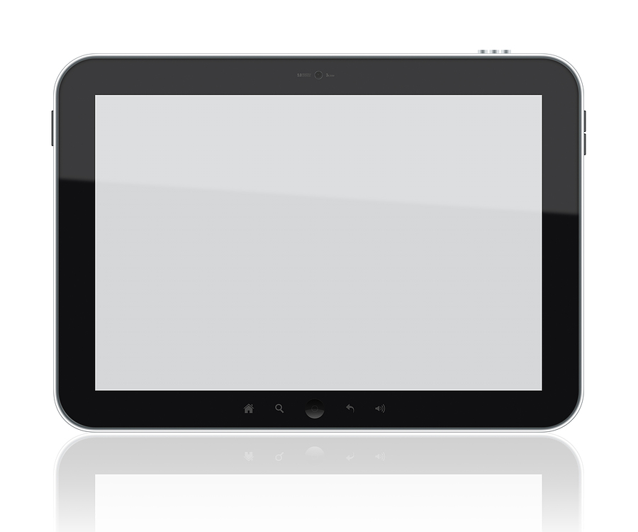
Language______________________
Building my dossier = Work in progress. For now, I am collecting my work here.

 | The title of my document | What skills did I use? | Date
1 | EXAMPLE:  “CHEZ MOI”  Writing about where I live | EXAMPLE:  Working as a group;  planning my work thoroughly;  creating my own word bank | 15.01.2014
2
3
4
5
10

CONTENTS PAGE

Building my dossier = Work in progress. For now, I am collecting my work here.
 | The title of my document | What skills did I use? | Date
1
2
3
4
5
6
7
8
9
10

CONTENTS PAGE

