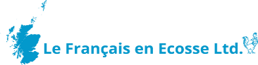
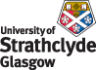
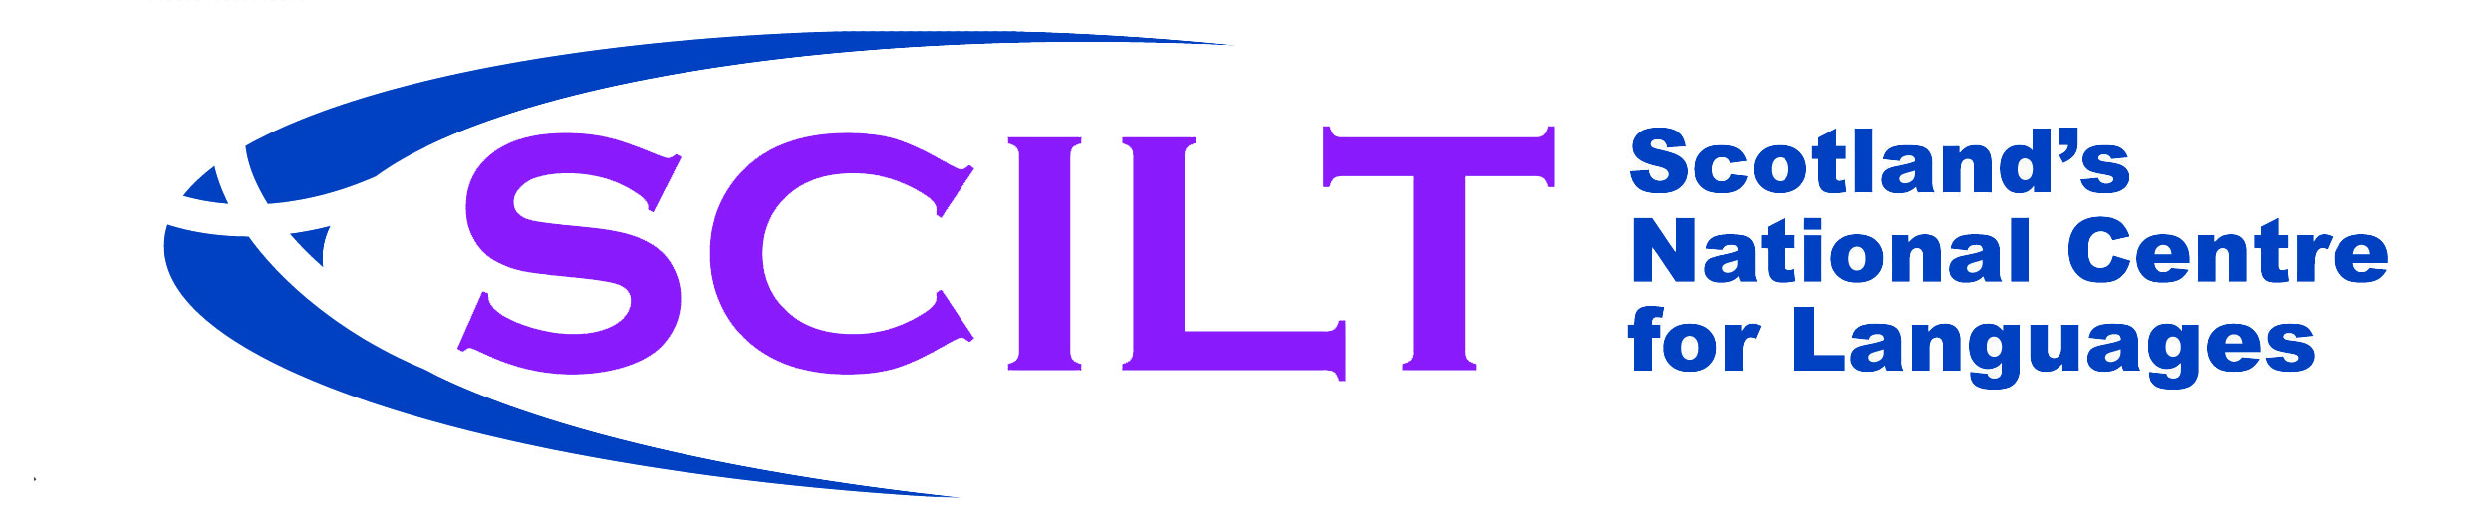
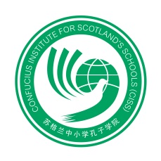
Teacher Notes: Geography
Geography  Focus | Suggested information | Suggested Activities | Suggested Language | Chinese Characters | Chinese Pinyin | NOTES/  COMMENTS
Geography | Highlight five key facts about China e.g. cities, languages, ethnic minorities, mountains, rivers, food, festivals, the countries which border with China | How do these compare and contrast with Scotland?  Identify the surrounding countries. Consider how each of these will have influenced China and compare to the UK: how many countries border the UK?  Link to e-book 1- The Happy Emperor | China  Scotland  Mountain | 中国  苏格兰  山 | Zhōngguó  Sūgélán  shān
Interesting facts about Russia | Interesting facts about Russia e.g. it is geographically the biggest country in the world, it has always had very strong links with North East China (language, architecture) | Explore the Trans- Siberian Train Route  Link to e-book 3 | Train  Aeroplane  Bus  I travel  I go | 火车  飞机  公交车  我旅行  我去 | huǒchē  fēijī  gōngjiāo chē  Wǒ lǚxíng  Wǒ qù
Beijing | Beijing: Capital, population, famous sights, the meaning of Beijing, link Bei (North) to other points of the compass (Nan, Dong, Xi) | Draw and label compass points and discuss other cities in China which have a compass point in their name | North  South  East  West | 北方  南方  东方  西方 | běifāng  nánfāng  dōngfāng  xīfāng
The Great Wall | The Great Wall; history, when built, why it was built, who built it; it's known as the longest cemetery in the world. Geographical coverage | Find out the Chinese word for Great Wall & its literal meaning.  Make your own Great Wall in the classroom | The Great Wall | 长城 | Chángchéng
The Cities | The cities: Identify where the cities are  Find out the meaning of Shanghai.  Identify the surrounding countries. Consider how each of these will have influenced China and compare to the UK: how many countries border the UK? | Divide pupils into groups to research each city. Market the researched city to the rest of the class, as a travel agency. This can be presented in a variety of ways e.g. power point, presentation, poster, brochure. | Above or up  Sea | 上  海 | shàng  hǎi
The Landmarks | Landmarks: Identify where the major landmarks are located on the map.  The Great Wall - revise previous facts | Compare the differences between major Chinese and Scottish landmarks.
Forbidden City | The throne of the emperor is known as the Dragon's seat. The Phoenix was the symbol of the empress. The empress throne is known as the Phoenix seat. | Can they link a Phoenix with a book or story they known? What is a Phoenix?  Forbidden City - research Emperor and Empress, dynasties, 9999 rooms, the symbolism of the colours yellow, blue, green, red.  Look at the significance of numbers in China. 9 is the emperor's number. 10 would be a greater being or a god.  Discuss how the numbers progress from ten in Chinese and identify patterns | Yellow  Blue  Green  Red  Dragon  Numbers one to ten | 黄色  蓝色  绿色  红色  龙  一  二  三  四  五  六  七  八  九  十 | huángsè  lánsè  lǜsè  hóngsè  lóng  yī  èr  sān  sì  wǔ  liù  qī  bā  jiǔ  shí
Yangtze River | What other rivers are famous in China (Yellow River)? What Scottish rivers do you know?  The Three Gorges dam is on the Yangtze River. It is the biggest hydroelectric dam in the world. This caused a lot of controversy as many old buildings were lost and people had to move during to village submersion. | Discuss where it begins and ends. Compare the length of the river to other rivers in the world.  Find out and discuss the impact these two main rivers have had in the lives of people? For example, floods, sustainability (food, wildlife, famine, rice fields). | Water  River  Lake  Mountain  Power | 水  河  湖  山  力量 | shuǐ  hé  hú  shān  lìliàng
Terracotta Warriors | Terracotta Warriors: Who commissioned them, why, where are they, who built them, what did they look like, how long did it take, how were they found and when. What happened to the Terracotta Warriors throughout history? | Link to e-book, the Emperor's Army.  What is Terracotta, what does it mean? The class could make their own warriors from clay or paper.  Explore the meaning of Terracotta (Terra from earth and Cotta from the word to bake or to cook) | Big  Small  Horse  Face  Head  Eyes  Nose  Mouth  Arms  Legs | 大  小  马  脸  头  眼睛  鼻子  嘴  胳膊  腿 | dà  xiǎo  mǎ  liǎn  tóu  yǎnjīng  bízi  zuǐ  gēbó  tuǐ
The Bund in Shanghai | The Bund in Shanghai: Where in Shanghai is it? What is it? How long is it?  What is it famous for? Who built it? | Research the name of the river which flows along the Bund  (The Pearl River)  Find out the other famous buildings on the opposite side to the Bund | Person  To follow  Crowd | 人  从  众 | rén  cóng  zhòng
Giant Pandas | Giant Pandas: Find out which area they are from in China? Find out about other endangered species in China and in other countries. | Link to e-book, the Happy Emperor.  Research the giant panda, discuss the pandas in Edinburgh zoo. | Black  White  I am called  He is called  She is called  I like  He likes  She likes  To eat  To drink  Bamboo | 黑色  白色  我叫  他叫  她叫  我喜欢  他喜欢  她喜欢  吃  喝  竹子 | hēisè  báisè  Wǒ jiào  Tā jiào  Tā jiào  Wǒ xǐhuan  Tā xǐhuan  Tā xǐhuan  chī  hē  zhú zi
Yellow Mountains | Yellow Mountains.  Find out where they are, if they are inhabited. What other mountain areas are there in China | Compare and contrast the Yellow Mountains to our mountains in the UK. | Recap yellow  Recap mountain  North, South, East, West

